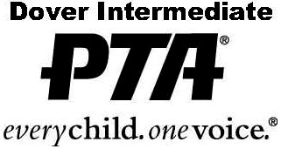
Officer & Committee Reports
Please submit to President at the completion of your event/term.
- Committee Name: Click here to enter text.
- Committee Chair(s): Click here to enter text.
- In order to ensure a successful event, what time in the year did you begin preparations? Feel free to submit a timeline with this report. Click here to enter text.
- List your expenses and amount spent below. Did your budget meet your needs? If not, why: Click here to enter text.
- Are any new supplies/equipment needed for next year? Click here to enter text.
- Please list the vendors you used below. Would you recommend these vendors again? Click here to enter text.
- How many volunteers were needed to get the job done? Please describe their duties/assignments. Click here to enter text.
- Please estimate your annual volunteer hours for this position.
Service Hours (regular PTA work): Click here to enter text.
Legislation Hours (writing legislators, working on levy issues): Click here to enter text.
Ways & Means Hours: (working on fundraising projects): Click here to enter text.
- Submit with this report any flyers or correspondence that may have been sent to Hilliard families and/or school staff. Click here to enter text.
- Additional recommendations and/or comments: Click here to enter text.

Thank you for helping Dover Intermediate School PTA—past, present and future.

